**Tech Track Endpoint Testing Results**

**Test Case 1: (Creating a Record)**

**Action:** Insert a new record in the form of JSON object.

**Result:** A response should be received with the created user object and a success message.

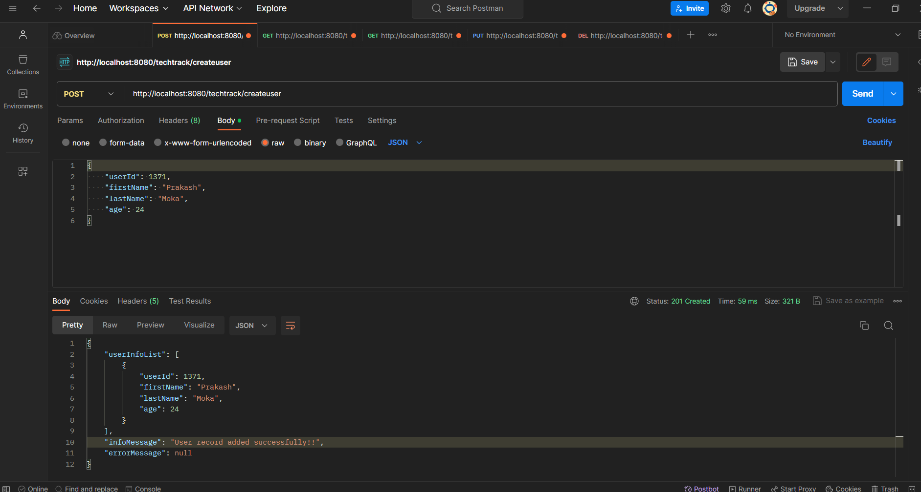

**Test Case 2: (Creating a Record)**

**Action:** Insert a new record with duplicate ID.

**Result**: The system shouldn’t allow to insert the record and should throw an error message.

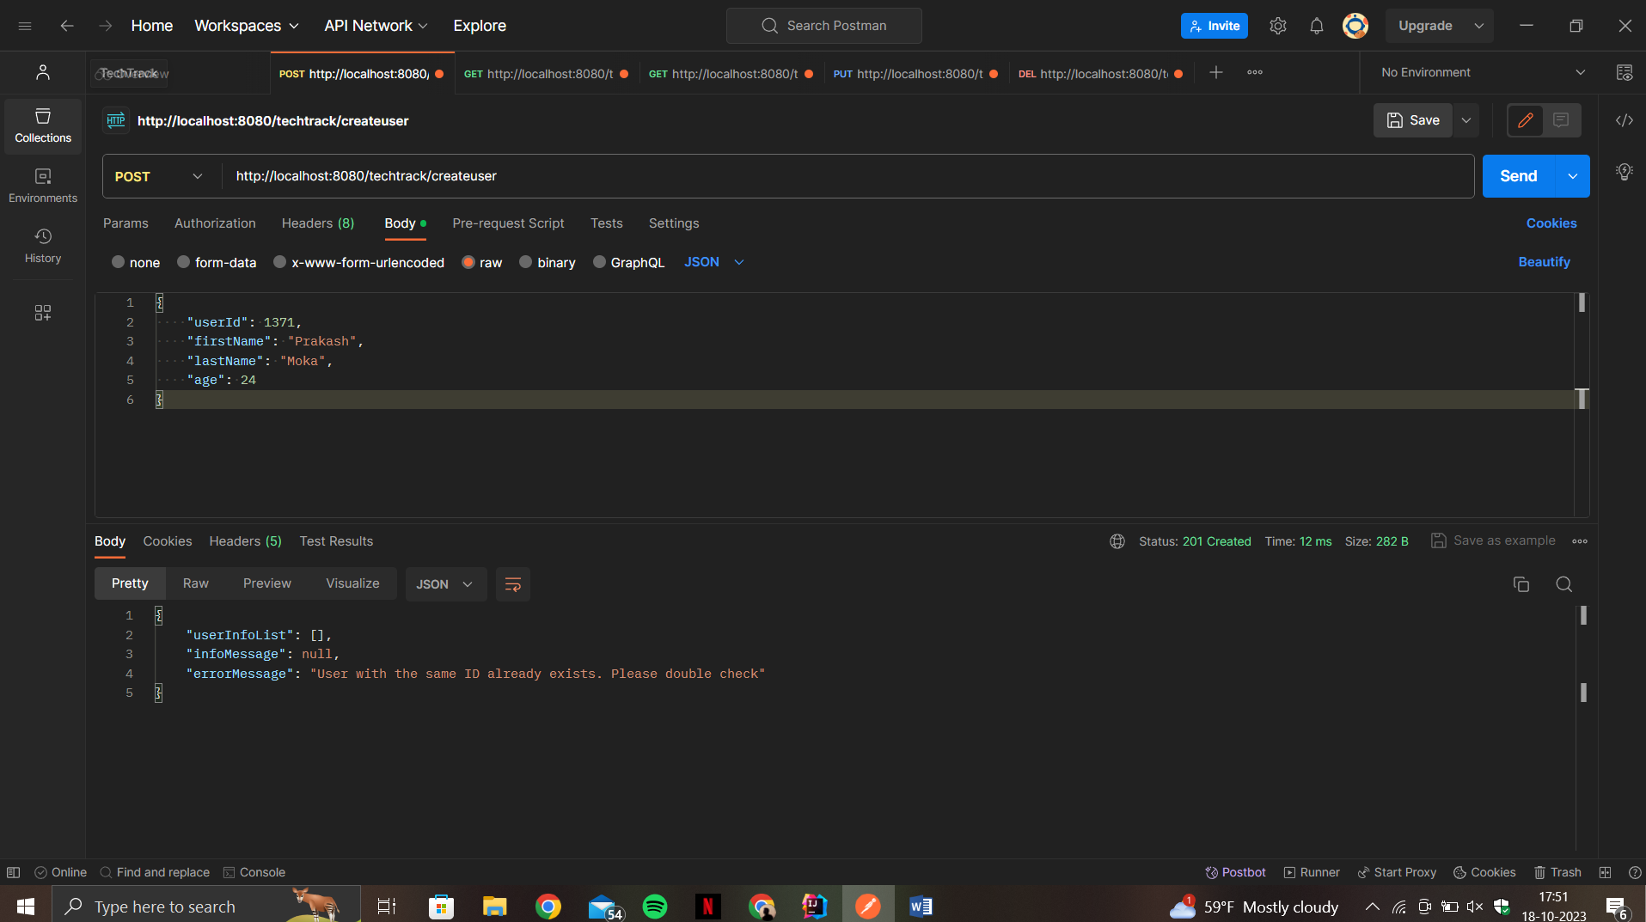

**Test case 3:(Read all records)**

**Action:** Try to get all the users when the list is empty.

**Result:** A response should be received with an appropriate info message.

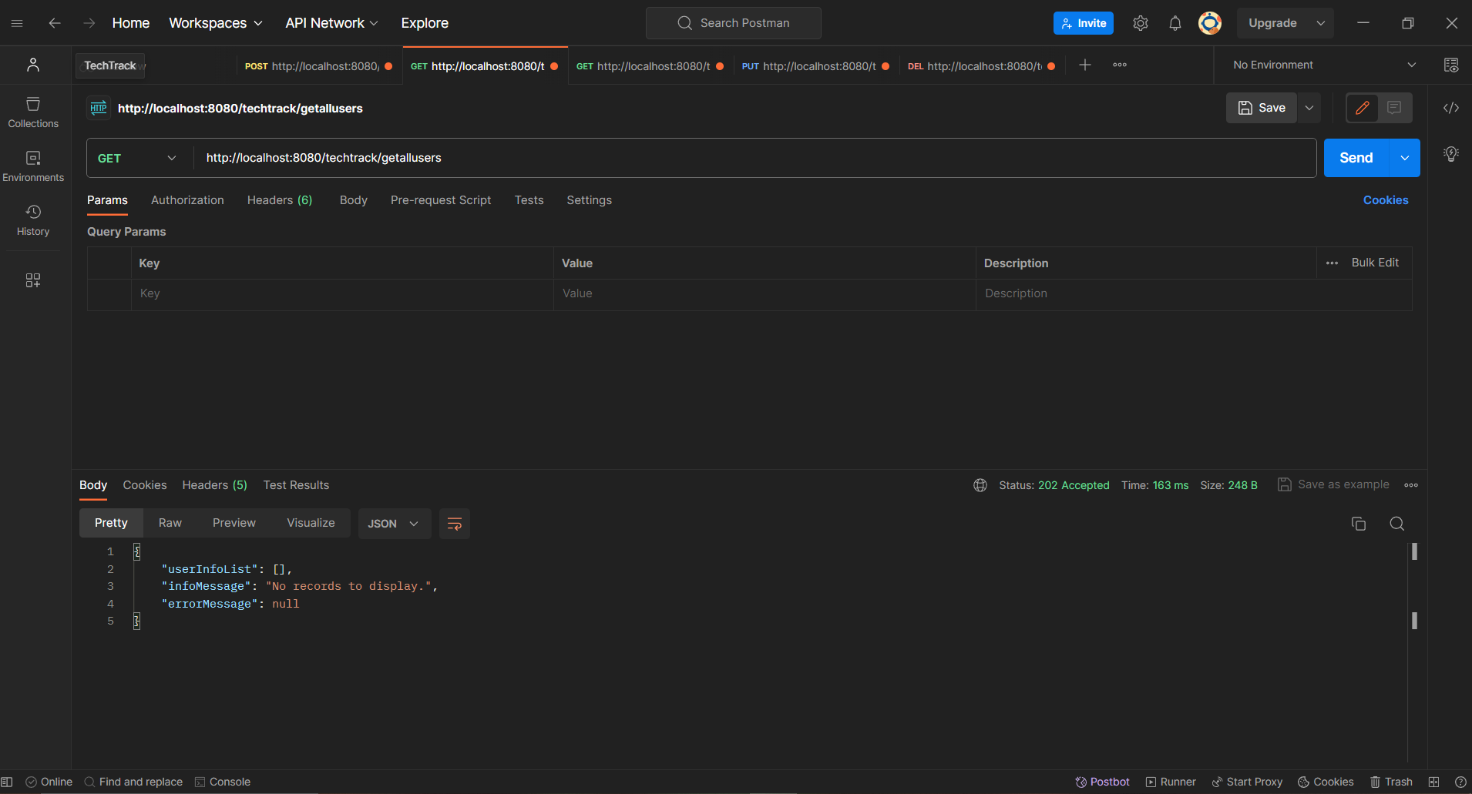

**Test case 4: :(Read all records)**

**Action:** Try retrieving all the records after inserting.

**Result:** A response should be received with all the user records contained in it.

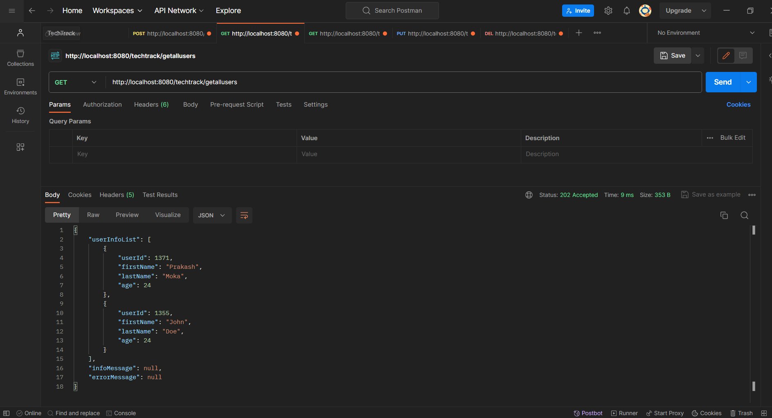

**Test case 5: (Read record by ID)**

**Action:** Try passing the ID along with the URL.

**Result:** The record should be fetched with the given ID and should be displayed.

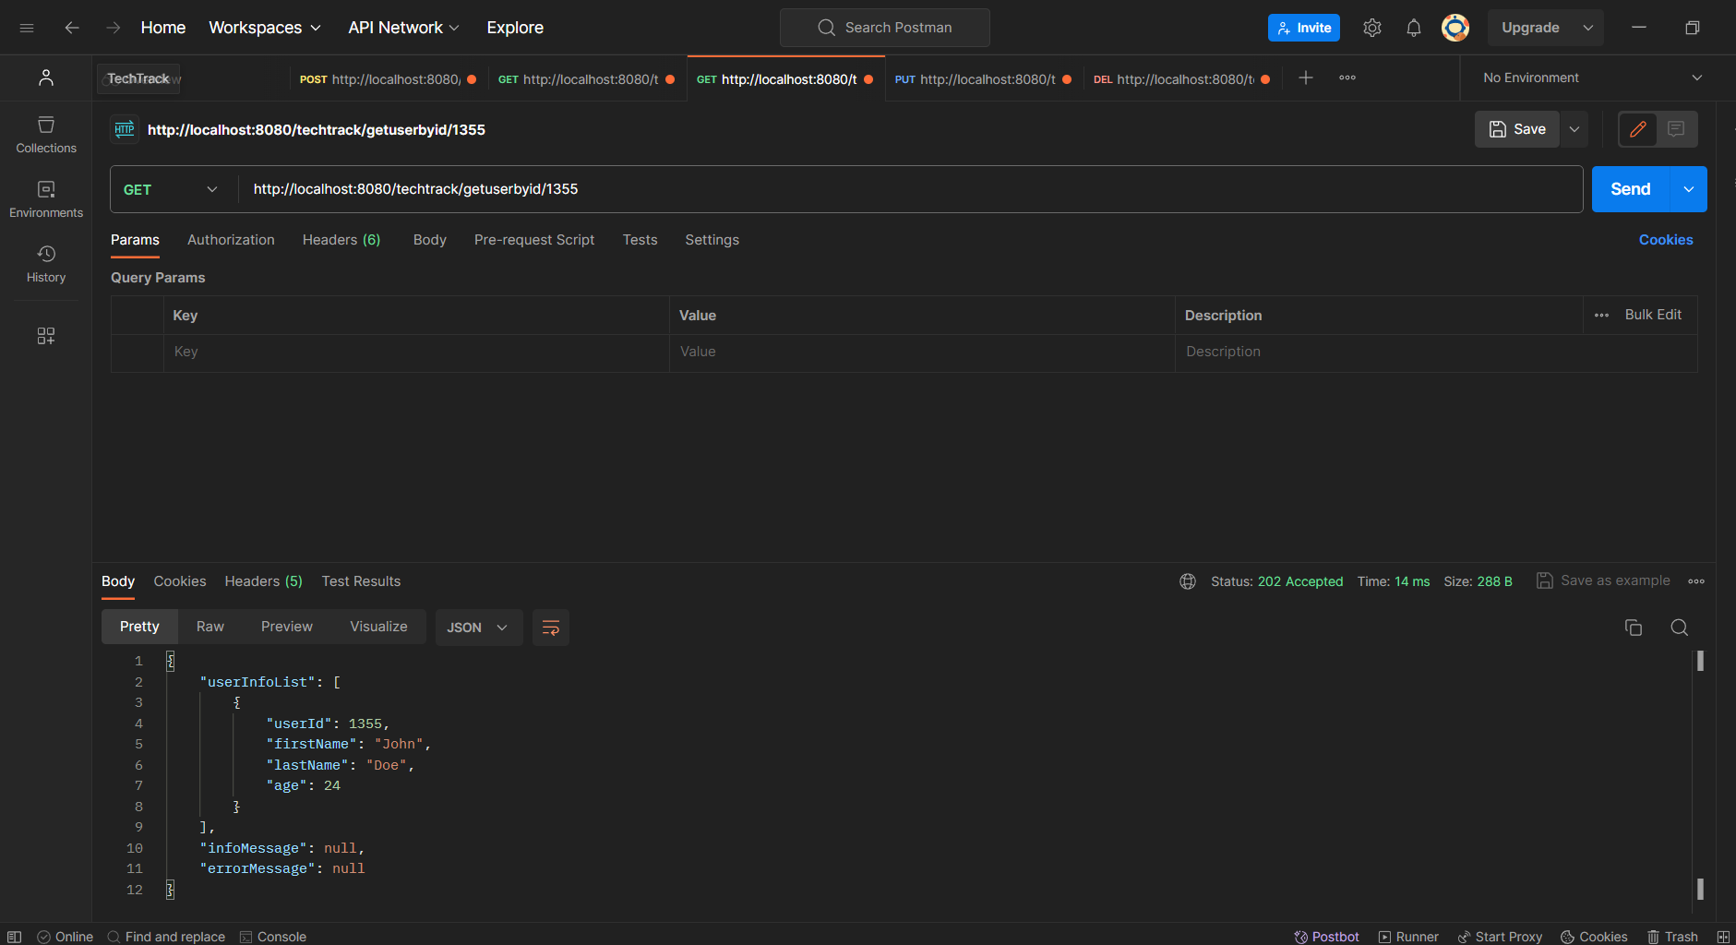

**Test case 6:** **(Read record by ID)**

**Action:** Try passing an ID which is not existing in the list.

**Result:** A response should be received with the appropriate message.

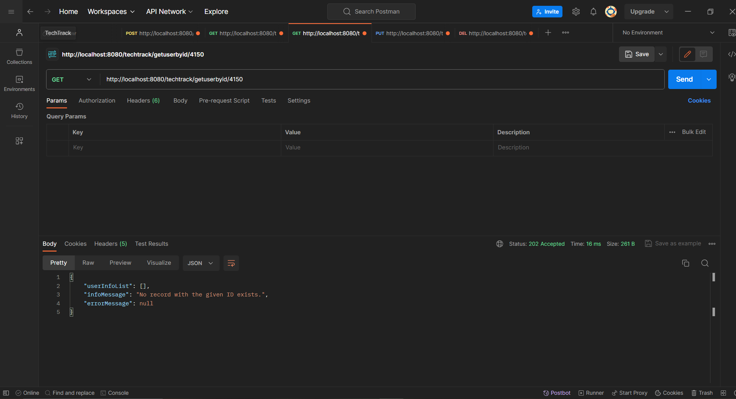

**Test case 7: (Updating the Record)**

**Action:** Try updating a record with the existent ID passing as a parameter in the URL.

**Result:** The user record should be updated.

**Before Update:**

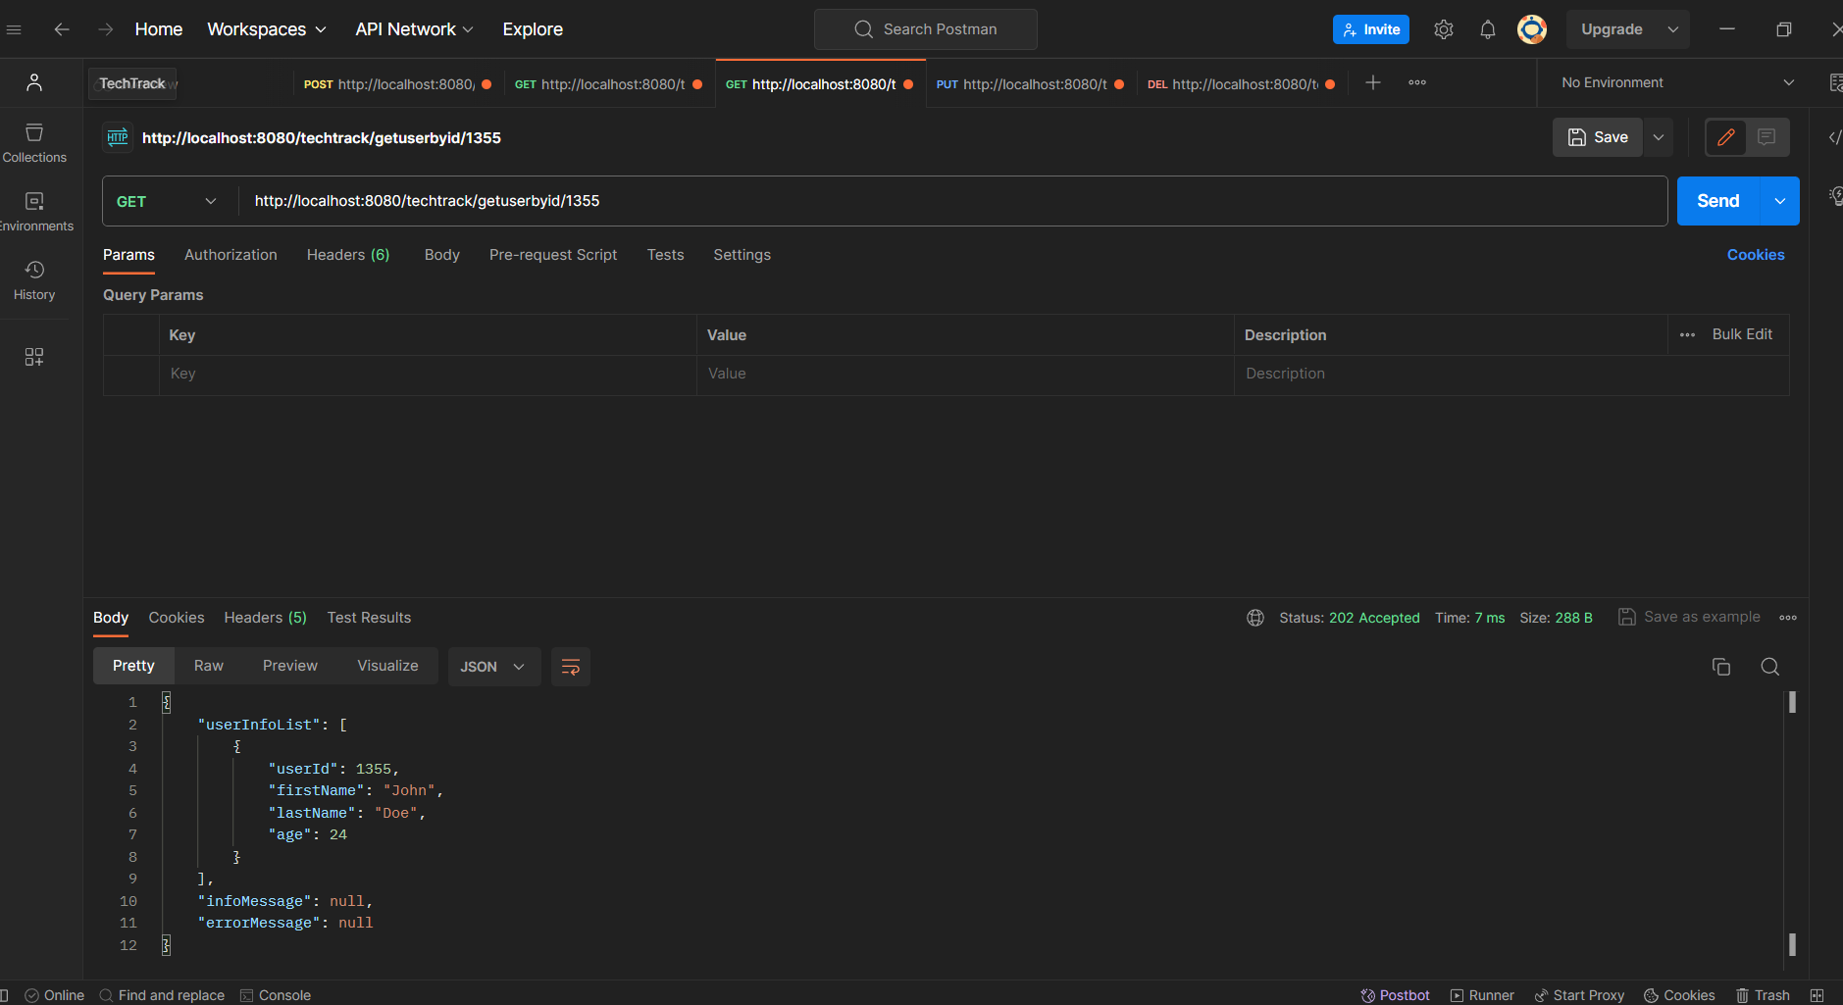

**During Update:**

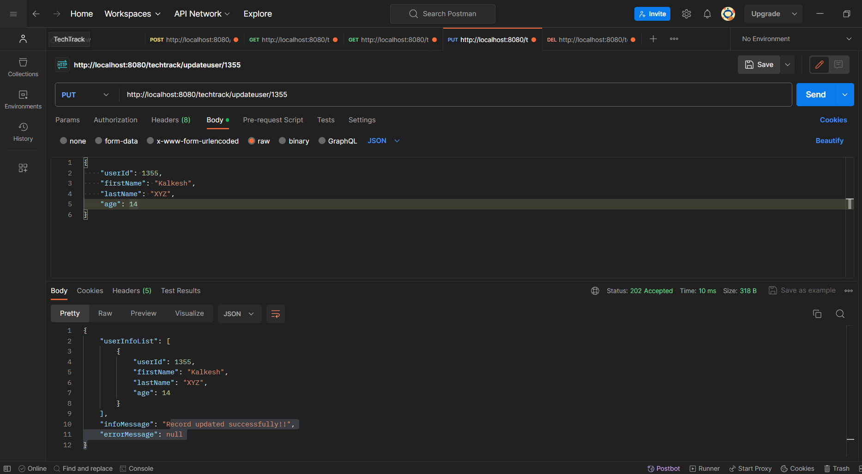

**After Update:**

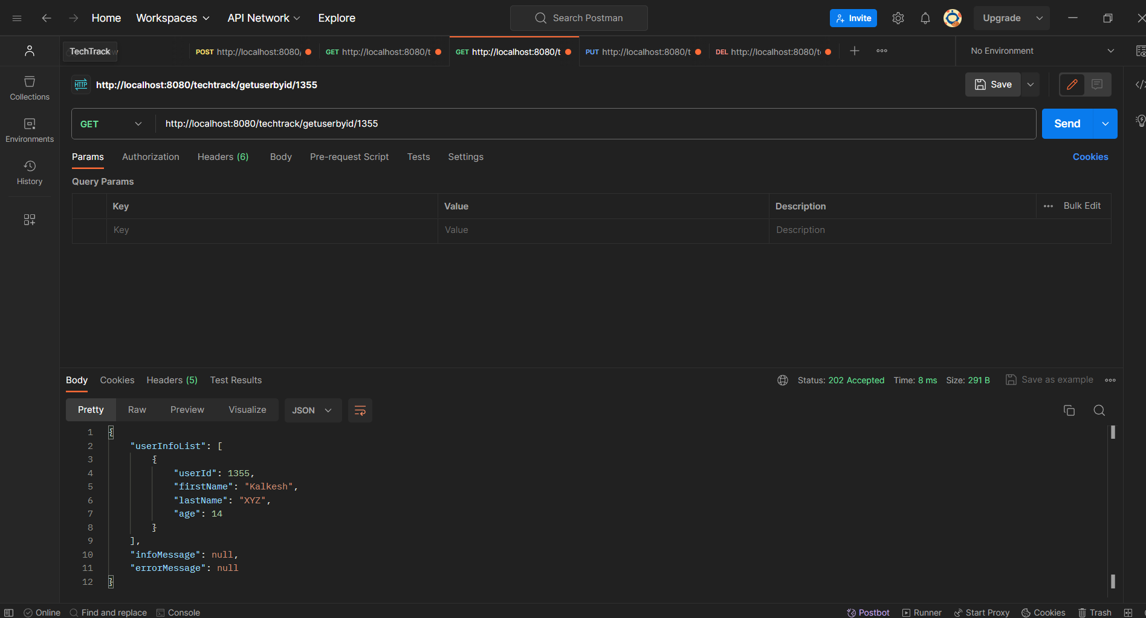

**Test Case 8: (Updating the record)**

**Action:** Updating a record with non existent ID

**Result:** A response with valid message saying that ID doesn’t exists should be displayed.

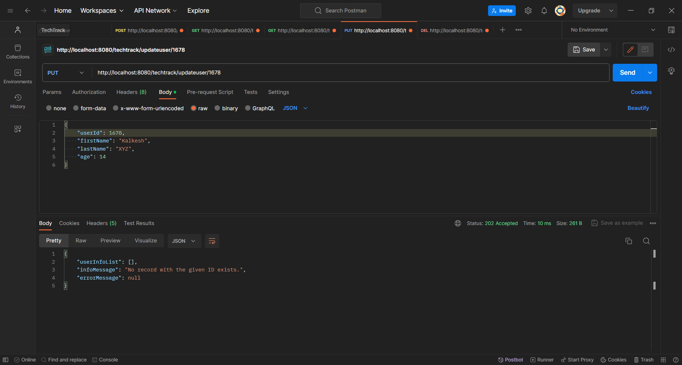

**Test Case 9: (Deleting a Record)**

**Action:** Delete a user record with an existing user ID.

**Result:** The record with the passed user ID should be deleted.

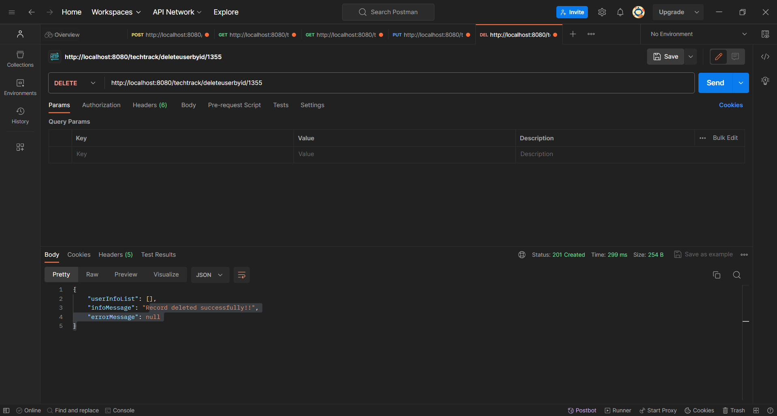

**Test case 10: (Deleting Record)**

**Action:** Delete a user record with a non existing user ID.

**Result:** A message should be displayed saying that the user ID doesn’t exists.

